The UK’s National Advance Care Planning Day 2026
Press Release. Embargo 9am (BST) 01/06/2026

The UK’s National Advance Care Plan Day (ACP Day 2026) will take place on the 1st July 2026. It is a day of awareness and action hyperfocused on the importance of Advance Care Planning.

On the 1st of July and during the surrounding week, care professionals will host their own Advance Care Planning events across the country. They are able to add their own event on the ACP Day website where it will be promoted, shared and celebrated.

The National Conference will take place in Norfolk. It is free to attend both in person or virtually using a live stream. ‘Watch parties’ at care organisation’s places of work are encouraged.

"How grateful we'll be on our last day, that we took time now to plan ahead. ACP Day is a step towards making our wishes clear." - Dr Kathryn Mannix Retired palliative care doctor. Author of 'With the End in Mind' and 'Listen.'

Supporting people and communities who are marginalised

This year’s ACP Day theme is ‘Supporting people and communities who are marginalised’.

“It is vital that care planning is personalised to the physical and mental needs of each person entrusted to us” - Dani Ayre, Norwich and Norfolk University Hospitals NHS Foundation Trust & Advance Care Plan Day Co-Founder

Get involved

Charities, NHS Trusts, individuals and organisations who are passionate about Advance Care Planning are invited to get involved. Ways to do so include:

- Hosting your own event
- Sharing the ACP resources on social media
- Sharing your own ACP Day Story
- Attending the National ACP Day Conference (in person or virtually)

Charities are invited to share their own Advance Care Planning resources during ACP Day. When doing so, please use the #ACPDay2026 hashtag and the ACP Day team will help promote the resources shared.

Resources developed by the ACP Day team raise awareness and levels of empowerment. These can be downloaded from the ACP Day website The full list of resources can be viewed and downloaded by clicking here.

The National Advance Care Planning Conference

The National ACP Day Conference will take place in the John Innes Conference Centre, Colney Lane, Norwich. The agenda is as follows:

08.30 Coffee, Registration and Exhibition
- 09.15 Welcome, Clare Fuller, RGN MSc, Advance Care Planning Advocate, Educator & Coach, Founder of Speak For Me
- 09.30 to 10.15 ‘The Missing Bridge in Advance Care Planning’: volunteers, empathy and time to have conversations’ Dr Lindsey Crockett, Bill Thompson, Kate Barber, Care Choices Services, Suffolk.
- 10.20 to 11.10 ‘How to involve people with a learning disability in end-of-life care planning’: Irene Tuffrey-Wijne, Professor of Intellectual Disability & Palliative Care at Kingston University, London.
- 11.10 - 11.55 Coffee and Exhibition
- 11.55 to 12.40 ‘Supporting People and Communities who are Digitally Marginalised’: James Norris, Founder of MyWishes, MyWishes Care and the Digital Legacy Association.
- 12.45 to 13.30 ‘Equity-oriented advance care planning – reflections from the No Barriers Here project 5 years on?’: Dr Jed Jerwood (PhD) Advanced Clinical Academic Art Psychotherapist - Birmingham and Solihull MHFT, Honorary Clinical Associate Professor - University of Birmingham.
- 13.30 - 14.30 Lunch, Exhibition & Networking
- 14.30 to 15.15 ‘Advance Planning and Neurodivergence - Towards Accessible Approaches’: Dr Emma Clare, Chartered Psychologist, End of Life Doula, and founder of Death Wired Differently.
- 15.20 Reflections: by Dr Kathryn Mannix,
- Reflections and Close

Chairperson: Clare Fuller, RGN MSc, Advance Care Planning Advocate, Educator & Coach. Founder of Speak For Me.

About Advance Care Plan Day

ACP Day 2026 and the national conference are organised by passionate Advance Care Planning advocates from Norfolk & Norwich Hospitals Charity, MyWishes Care, Speak for Me and Norfolk and Norwich University Hospitals. ACP Day is a not for profit awareness day now in its third year.

ACP Day 2026 has partnered with Sue Ryder, a charity that shares ACP Day’s mission and values.

“We are proud to be partnering with the National Advance Care Plan Day. Sue Ryder is committed to equipping healthcare professionals with the knowledge and skills to approach sensitive conversations with compassion and wisdom. These conversations can help people to plan for the end of their life, capturing their wishes for the care and treatment they will receive, reflecting their values and beliefs whilst ensuring that what matters most to each person is recognised and respected.” - Anne Castle, Bereavement Training Lead at Sue Ryder

www.AdvanceCarePlanDay.org

Notes for editors

- Video for use online https://www.youtube.com/watch?v=1a-tr_b_Dyc
- Images and assets for online and print https://drive.google.com/drive/u/4/folders/1NL9rbBhnmmyfqykLM_-05TIajCOeqAFe

Image and assets examples for online and print

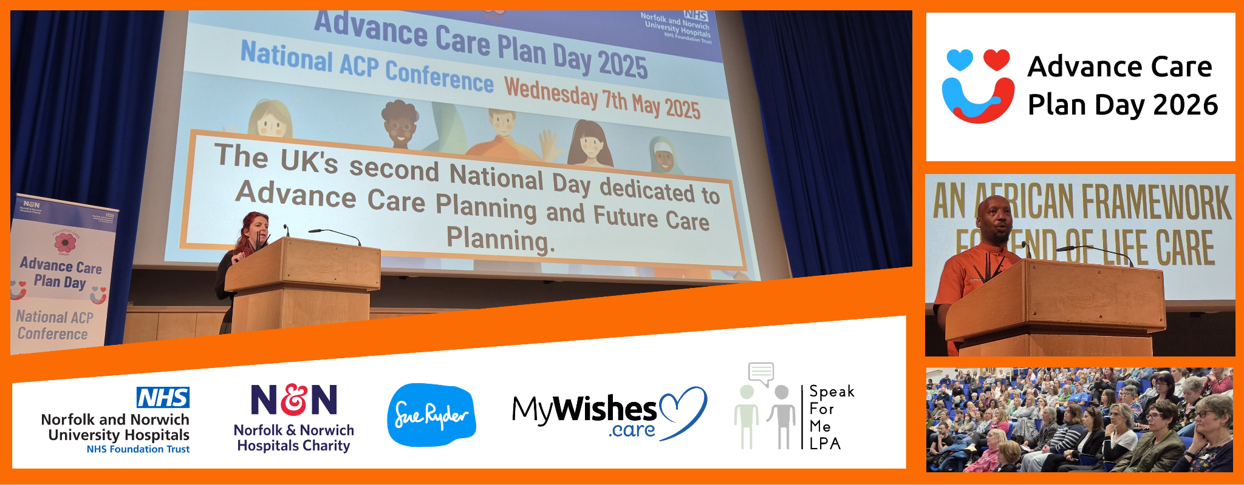
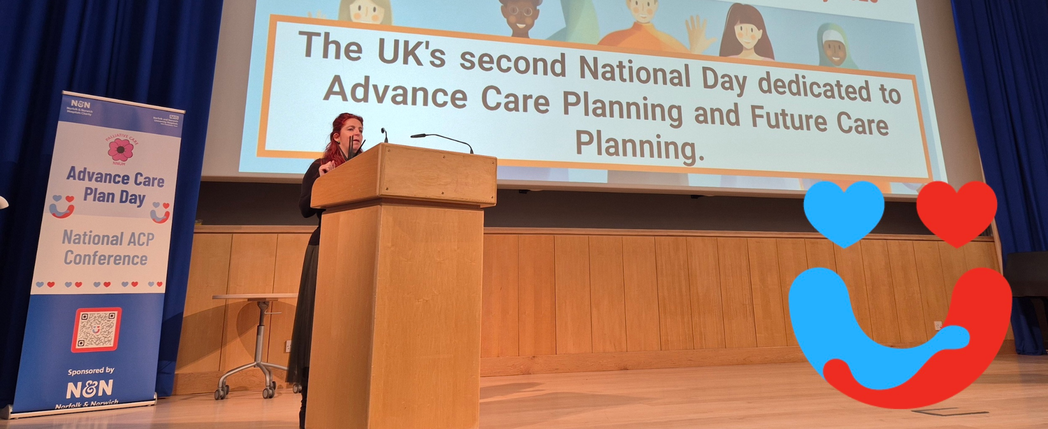
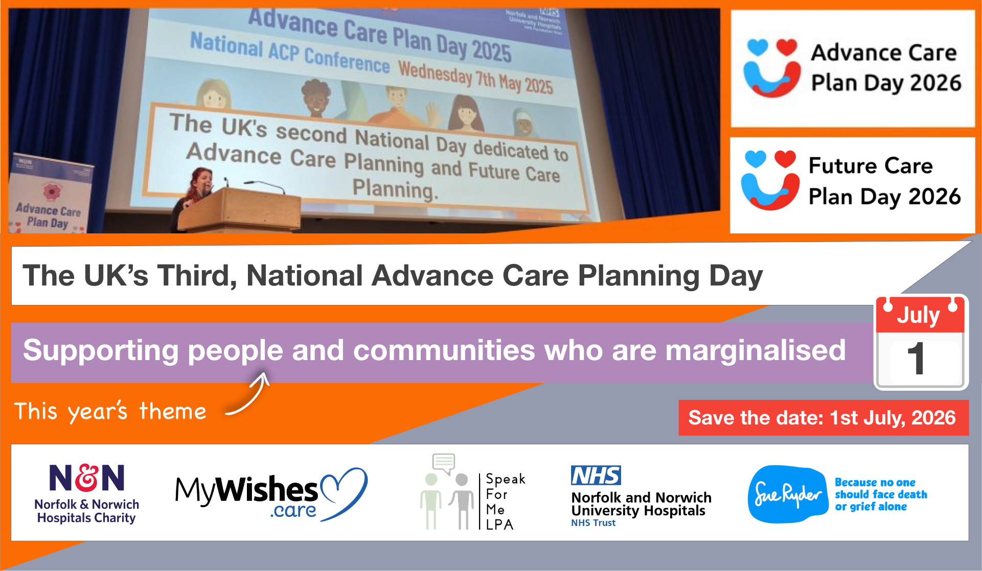

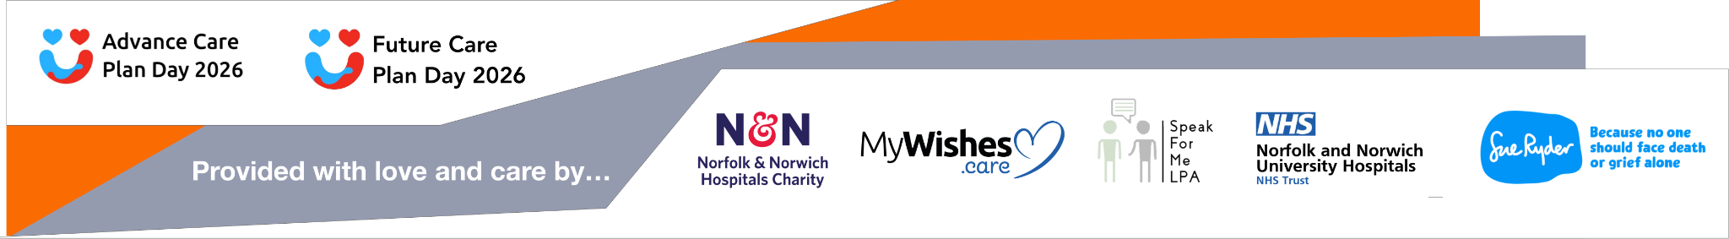

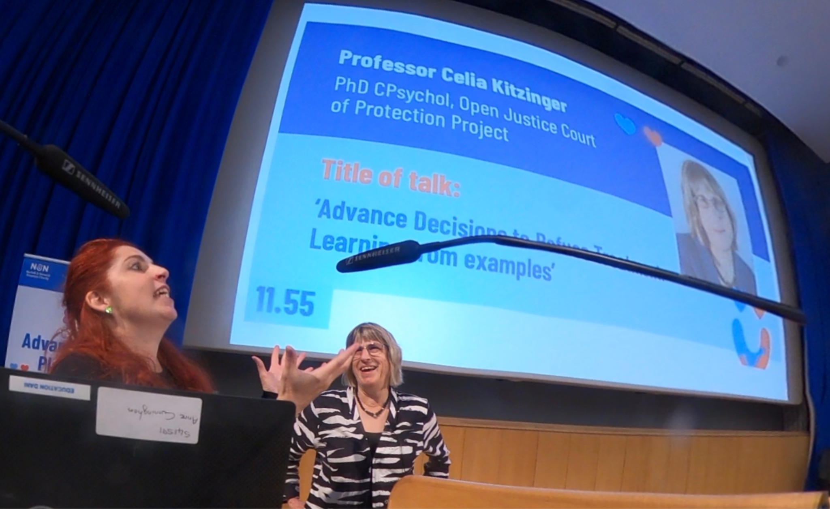

All assets and images: https://drive.google.com/drive/u/4/folders/NL9rbBhnmmyfqykLM_-05TIajCOeqAFe

